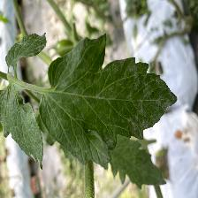

**Fully**

**Connected**

Healthy

PM

TSWV

**Softmax**

**Feature Extraction**

**Classifier**

**Convolution**

**Batch Normalization + ReLU**

**MaxPooling2D**

**Depth-wise Separable convolution**

**Feature Extraction**